Application and Interview Tips
We are delighted you are interested in joining our amazing mutual.
You will find some useful information relating to your application and the interview process below along with some tips for success:
- We appreciate the time and effort that goes into applying for a job and give every application the attention it deserves. However, in cases where there is a high number of applications, the shortlisting pass mark may need to be adjusted and candidates will be invited to interview in merit order, i.e., those scoring the highest.
- Should you be invited to interview, you will be assessed using various assessment techniques which will seek to gain a better understanding of your behaviours, competencies, and values in line with those outlined in the advert.
- At present, the majority of our interviews are being conducted by Video Conference unless a practical assessment is required i.e., Carpenter roles
- You may not have done an interview before or perhaps you just need a refresher. Careers Wales has lots of useful information regarding Interview Techniques that you may find helpful here
- We strongly recommend using the STAR technique when answering interview questions to ensure you are providing us with full, well-rounded answers which are specific in nature.

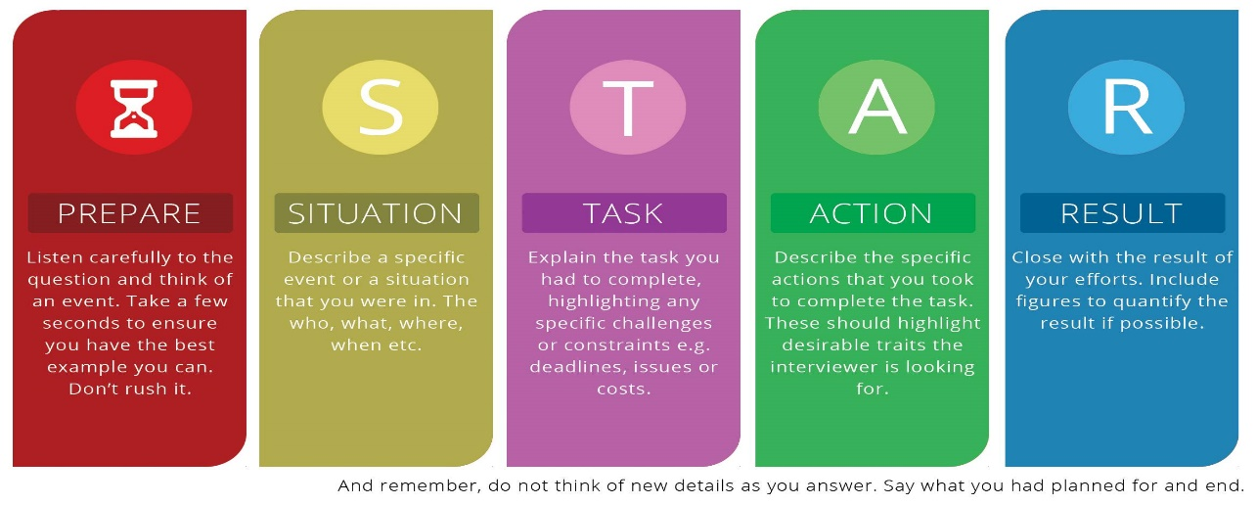

- You can find an excellent tutorial on how to use the STAR technique successfully here
- If you have been asked to submit a video application, we know this can be daunting, but these are a great way for us to see a little more of your personality so please do your best to relax and just be yourself. Feel free to keep it nice or get as creative as you like. You can find some guidance before you get started here, here and here.
- Depending on the role you are applying for ,you may be asked to give a presentation, again this is a great way for us to learn more about you and the way you think and engage with different audiences It may sound basic, but it is important if you are asked to make a presentation that you stick to the timeframe and answer the question you are being asked. You may find this video useful. If your presentation is online, this video contains some useful tips also.
- It may sound obvious, but make sure your CV is up to date and that it successfully demonstrates your experience in line with the essential criteria for the role you are applying for
- You can find a CV template here or If you need help with any part of the application process please email human.resources@mvhomes.org.uk or call us on 0800 085 7843
- Please also get in touch If you would like this document explained, translated or provided in another format such as large print, audio or Braille
- A reserve list may be held for a period up to 12 months from which further appointments may be made.
We wish you all the best with your application and do not hesitate to get in touch if we can be of assistance!

